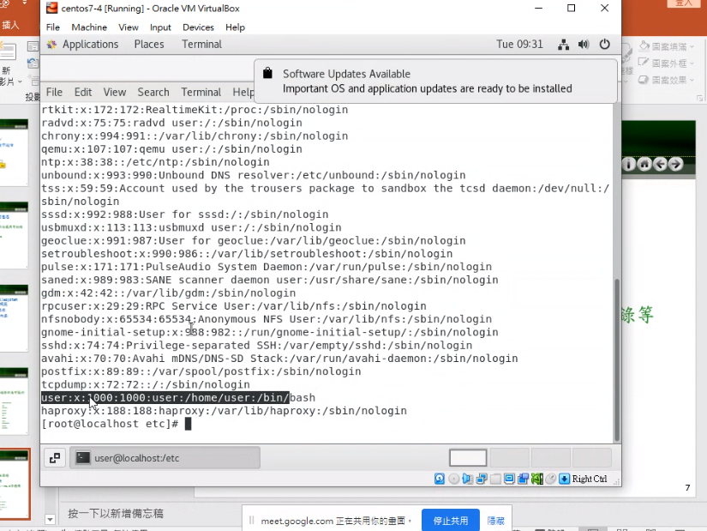

If above 1000 means, its super user

If below 1000 means, its normal user

Cat /etc/shadow

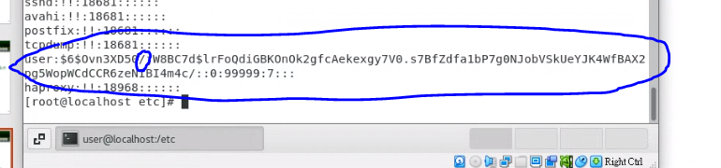’

The first column is username, and the next column is the password

Cat /etc/resolv.conf

Ping tw.yahoo.com

Inittab

Resolv

Fstab

Rc.d

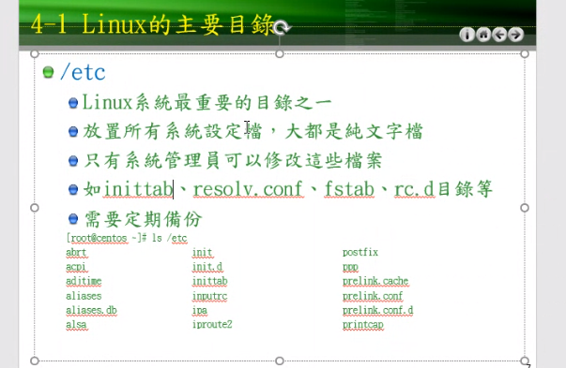

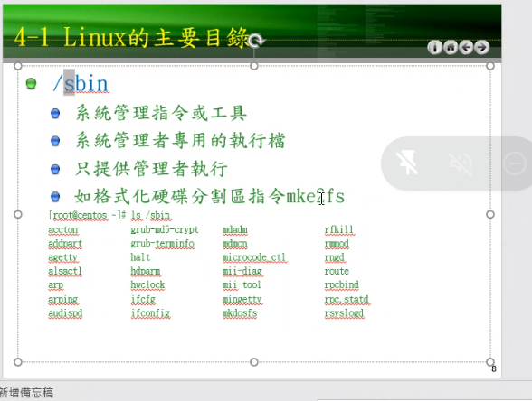

/sbin

Is the binary file of the user

Windows linux

Arp -a arp -n

Cd /boot

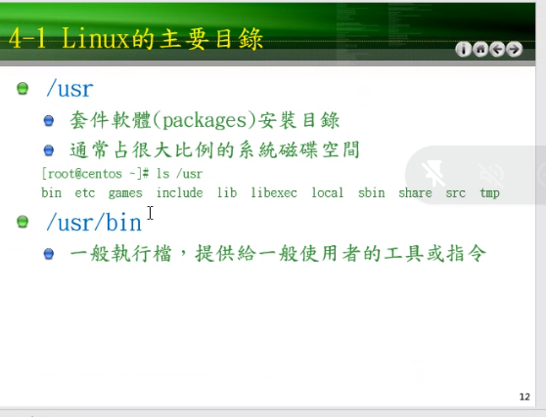

/usr

/usr/bin

Touch a

\*\*use to create an empty file

Ln a link

\*\*use to link folder “a” to “link”

Mkdir testdir1

// allows users to create or make new directories. mkdir stands for “make directory.”

Yum install tree